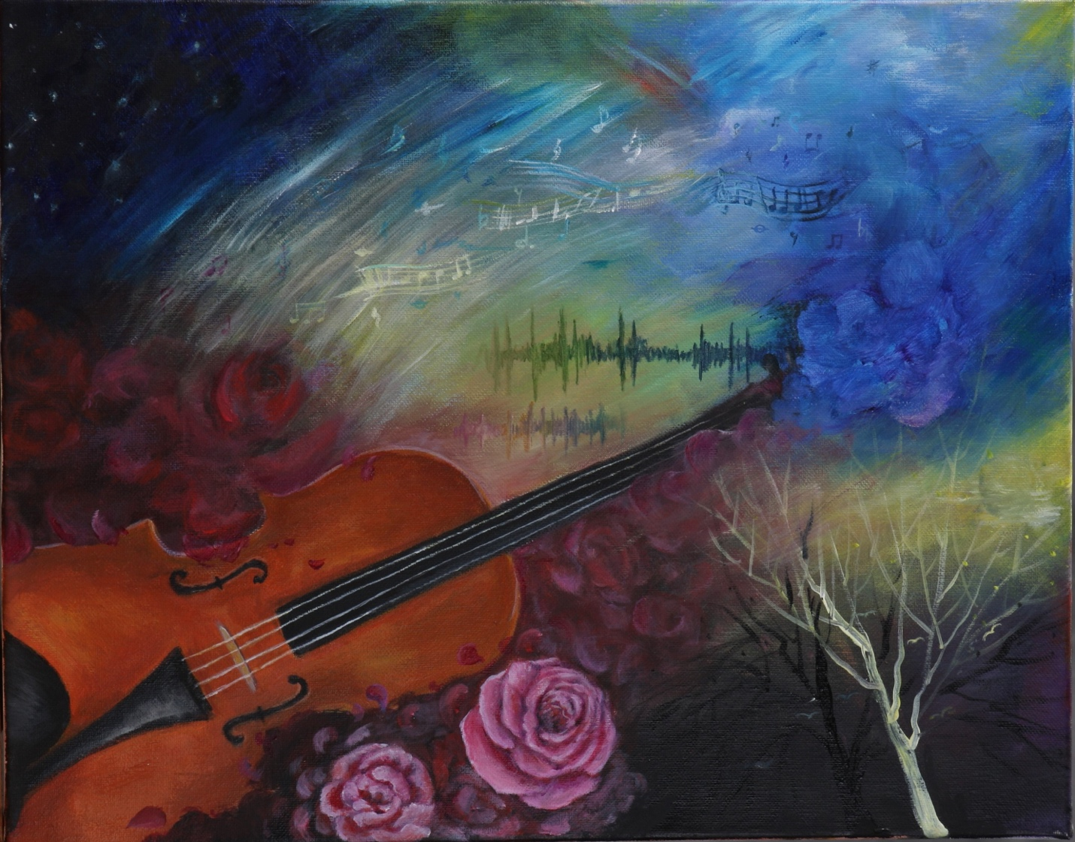

Music is not just an auditory experience, as it can take on many different forms. Music conjures vivid images in the mind’s eye and, on a quantitative level, is represented by notes, chords, and sound waves. This piece captures multiple facets of music, from the literal to the figurative, and the different ways in which the art form can be interpreted. Motifs from nature such as roses and trees are dispersed throughout, and cool and warm colors are juxtaposed to create a striking effect of contrast.

